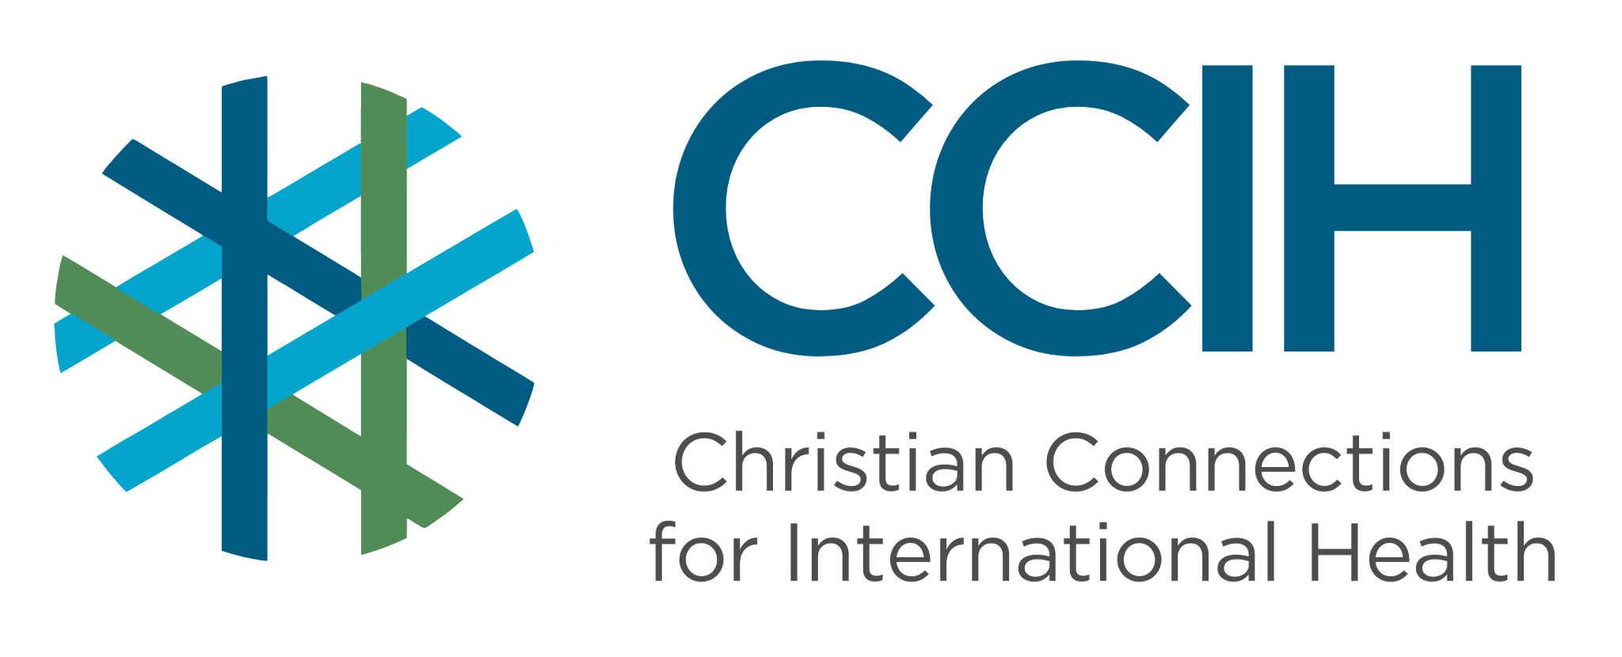
ADOLESCENT HEALTH – Talking Points for Faith Actors

What is it?
Adolescent health refers to the physical, mental, and social well-being of young people between the ages of 10 and 19. The health challenges young people face during these years are wide-ranging, including nutrition, infectious disease, mental health, substance use, violence, reproductive and sexual health, and injuries.

Why is it important?
Sub-Saharan Africa (SSA) is home to more than 250 million adolescents, over 20% of all adolescents in the world, and that number is growing. Young people in this region have death rates twice as high as those in other regions and face some of the highest rates of preventable disease, pregnancy complications, malnutrition, and mental health challenges for adolescents globally. Investing in the health and well-being of young people during these years can break cycles of poverty, prevent disease, and build stronger families and communities for generations to come.

Key Trends and Challenges
Current Trends and Statistics

- SSA has the highest adolescent death rate in the world.
- In the African region, the leading causes of death among older adolescent girls are pregnancy-related, while among older adolescent boys, it is tuberculosis, interpersonal violence, and HIV/AIDS. For younger adolescent boys and girls, the leading causes of death are communicable diseases, HIV/AIDS, lower respiratory infections, and malaria.
- SSA has the highest rate of adolescent pregnancy in the world, and adolescents have more complications in pregnancy, childbirth, and postpartum.
Challenges and Gaps in LMICs
- Many adolescents have little or no access to accurate health information.
- Adolescent-friendly health services are rare in SSA; young people often feel too embarrassed, judged, or unwelcome to seek care at adult health facilities.
- Harmful social pressure pushes girls into child marriage and childbearing before their bodies and minds are ready and puts girls at risk for gender-based violence.
Populations Most Affected
- Adolescent girls, who face higher risks of early pregnancy, child marriage, gender-based violence, and HIV infection.
- Young people living in rural areas with limited access to schools, health education, and medical care.
- Adolescents living in poverty, conflict, or displacement, where health risks are multiplied, and services are limited or non-existent.
- Out-of-school youth who have no access to health education or support networks.
- Adolescents living with HIV, who face unique challenges accessing care and support.

Christian Connections for International Health (CCIH) is a global network of Christian organizations and individuals committed to advancing health and wholeness. Learn more at www.ccih.org.

A Faith-Informed Response

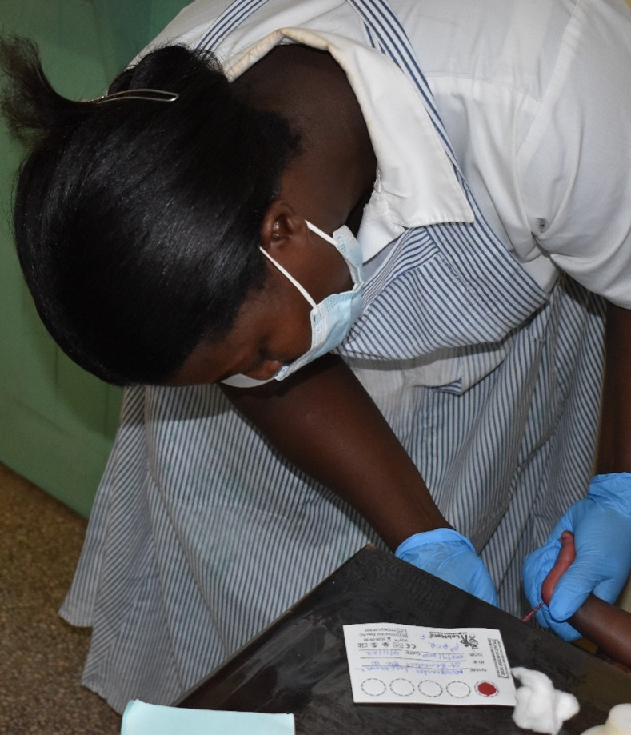
How are faith communities impacted?
- Adolescents are the future of every congregation. Yet many young people in faith communities are quietly struggling with early pregnancy, inadequate nutrition, substance use, mental health challenges, exposure to violence, and risky behaviors.

Why does this matter to faith communities?
- God created young people with dignity, purpose, and potential. Ensuring adolescents grow up healthy, educated, and safe is a matter of faith and justice. When adolescents in our congregations are sick or dying from preventable causes, the church has a responsibility to respond and to stand for the flourishing of every young person in its community.

Why should religious leaders act?
- Adolescents, especially girls, are rarely able to advocate for themselves. Faith leaders are trusted by both young people and their families in ways that health workers and government officials often are not. When a pastor speaks about the value of every young person's health and future, it carries weight that few others can match in congregations and the community. Faith leaders can also advocate with governments and health systems for better services for young people, creating the conditions where adolescents can grow up healthy and changing the course of young lives.

Related Scriptures

- "Start children off on the way they should go, and even when they are old they will not turn from it." Proverbs 22:6, NIV
- "Before I formed you in the womb I knew you; before you were born I set you apart." Jeremiah 1:5, NIV
- "Speak up for those who cannot speak for themselves, for the rights of all who are destitute." Proverbs 31:8, NIV
- "Don’t let anyone look down on you because you are young, but set an example for believers in speech, in conduct, in love, in faith, and in purity." 1 Timothy 4:12, NIV

Talking Points for Sermons, Meetings, and Social Media

Key Messages to Share
- Every young person in our congregation deserves to grow up healthy, safe, and full of hope, and our church has a role to play in making that possible.
- Child marriage and early pregnancy are not God's plan for our daughters. They cause real harm, and our church should say so.
- Keeping adolescents in school and connected to health services is one of the most powerful ways we can protect their futures.
How to Start the Conversation
- “Think about the young people sitting in this church today. Are they healthy? Are they safe? Do they have someone to turn to when they are struggling?"
- Share that most adolescent deaths and health problems in our region are preventable and that the church can be part of the solution.
- Invite young people themselves to share their experiences and needs.

Practical Actions for Faith Leaders and Communities


Advocate
- Preach about the full range of adolescent health, including mental health, reproductive and sexual health, nutrition, substance use, injury prevention, and access to healthcare.
- Partner with local schools and health clinics to support adolescent health education programs that address the issues young people face in your community.
- Advocate with local and national governments for youth-friendly health services that are affordable, accessible, and welcoming to both boys and girls.

Address Stigma and Misconceptions
- Create a culture in your congregation where young people feel safe asking questions, seeking guidance, and speaking honestly about the challenges they face without fear of judgment.
- Correct the idea that adolescent girls who become pregnant or are victims of sexual violence are to blame for what happened to them; they deserve compassion and support, not shame.
- Challenge the belief that adolescent health problems, including mental illness, substance use, or violence, are signs of spiritual failure or bad parenting. They are health issues that require empathy and care.
Refer People to the Right Services
- Know where adolescents in your community can access youth-friendly health services, including treatment for injuries or illness, nutrition resources, maternal health care, mental health support, and HIV testing, and share that information openly.
- Connect pregnant adolescents immediately to health care and ensure they receive compassionate support from the congregation throughout their pregnancy.
- Direct young people showing signs of mental health struggles, substance use, or exposure to violence to community health workers or counseling services as quickly as possible.

Resources

- For additional faith-based advocacy tools and biblical resources, visit the Christian Connections for International Health (CCIH) Resource Library, where you can search for “Adolescents” at https://www.ccih.org/resources/
- CCIH. Adolescent Sexual and Reproductive Health Guide. 2025: https://www.ccih.org/wp-content/uploads/2025/05/ASRH-Guide-April-2025.pdf
- National Action Alliance for Suicide Prevention, Suicide Prevention Resource Center, & U.S. Department of Health and Human Services Center for Faith-based and Neighborhood Partnerships. (2023). Hope: A guide for faith leaders to help prevent youth suicide. The Board of Regents of the University of Oklahoma. https://www.ccih.org/wp-content/uploads/2025/03/hope-guide-faith-leaders-help-prevent-youth-suicide.pdf
- Faith to Action Network. Navigating Adolescence – Lessons on ASRHR: Partnerships with Faith Actors. 2022. https://www.ccih.org/wp-content/uploads/2023/07/Navigating-Adolescence-ICFP-Side-Event-2022.pdf
- World Health Organization. Adolescent and Young Adult Health Fact Sheet. Geneva: WHO, 2024. https://www.who.int/news-room/fact-sheets/detail/adolescents-health-risks-and-solutions
- World Health Organization. Adolescent Pregnancy Fact Sheet. Geneva: WHO, 2024. https://www.who.int/news-room/fact-sheets/detail/adolescent-pregnancy
- UNICEF. Child and Youth Mortality Data Ages 5–24. 2024. https://data.unicef.org/topic/child-survival/child-and-youth-mortality-age-5-24/
- UNICEF. Ending Child Marriage. 2024. https://www.unicefusa.org/what-unicef-does/child-protection/end-child-marriage
- Álvarez Sánchez C & Tyler V. Improving Adolescent Health and Nutrition in Sub-Saharan Africa: The Time to Act Is Now. Maternal & Child Nutrition, 2025. https://doi.org/10.1111/mcn.70038
- WHO Regional Office for Africa. Country Fact Sheets on Adolescent Health. https://www.afro.who.int/publications/country-fact-sheets-adolescent-health
- WHO Regional Office for Africa. Adolescent Health. Brazzaville: WHO AFRO. https://www.afro.who.int/health-topics/adolescent-health

Why Does this Matter to Me? (Context-Specific) Use this space to write down your thoughts, prayers, data, or talking points.

