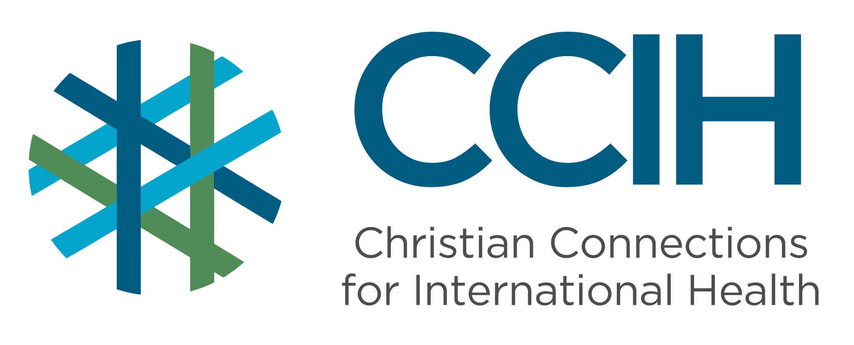
ANTIMICROBIAL RESISTANCE – Talking Points for Faith Actors

What is it?
Antimicrobial resistance (AMR) happens when bacteria, viruses, fungi, and parasites change over time and stop responding to the medicines that once slowed their growth or killed them. This means that infections that were once easy to cure, like pneumonia, blood poisoning, or tuberculosis, can become very difficult or even impossible to treat. AMR is often called a "silent threat" because it is invisible, but it is already causing more deaths in parts of Africa than HIV, malaria, or TB. AMR is driven largely by the overuse and misuse of antibiotics.

Why is it important?
Antibiotics and other antimicrobial medicines have saved hundreds of millions of lives over the past century. Without them, routine medical procedures like surgery, childbirth, and cancer treatment become life-threatening. If AMR continues to grow unchecked, we risk returning to a time when even a simple wound or common infection could kill. Sub-Saharan Africa (SSA) is already the region most affected by AMR in the world, and without urgent action, the problem will get much worse.

Key Trends and Challenges

Current Trends and Statistics
- SSA has the highest AMR death rate in the world, 23.7 deaths per 100,000 people, compared to just 5 per 100,000 in North America.
- AMR has now surpassed HIV, malaria, and TB as a cause of death in many parts of Africa, and AMR-related deaths are rising as deaths from those other diseases fall.
- Without urgent action, AMR could be responsible for up to 4.1 million deaths in Africa every year by 2050.
Challenges and Gaps in LMICs
- Many people in SSA buy and use antibiotics without a prescription, often because formal healthcare is too far away or too expensive; some people do not know how to use them correctly, and this drives AMR.
- Weak laboratory systems mean that resistant infections often go undetected and untracked, making it hard to know how serious the problem is or where it is spreading.
- Antibiotics are also widely overused in livestock and farming, which spreads resistant bacteria into food, soil, and water, affecting whole communities.
- Many health facilities lack the supplies and trained staff needed to prevent infections from spreading in the first place, leading to more antibiotic use.
- Public awareness of AMR is low; most people do not know that taking antibiotics incorrectly or unnecessarily makes them less effective for everyone.
Populations Most Affected
- Newborns and young children, who are especially vulnerable to resistant infections.
- People living with HIV, TB, or malaria, whose treatments are increasingly threatened by drug-resistant strains of these diseases.
- Patients in hospitals and health facilities, where resistant infections spread most easily.
- Farmers and people in rural communities where antibiotic use in livestock is common and unregulated.
- Low-income households who rely on self-medication with leftover or counterfeit antibiotics because they cannot afford proper healthcare.

Christian Connections for International Health (CCIH) is a global network of Christian organizations and individuals committed to advancing health and wholeness. Learn more at www.ccih.org.
A Faith-Informed Response
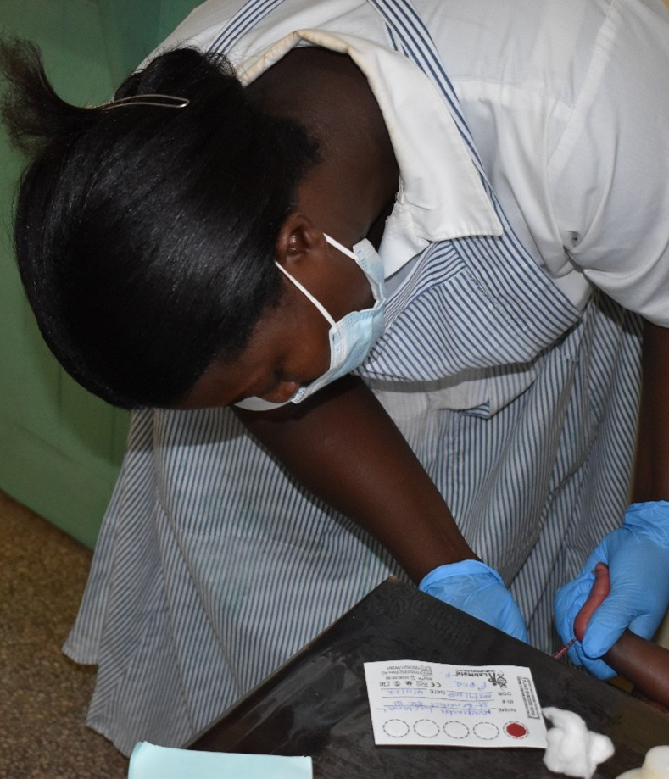
How are faith communities impacted?
- AMR is already changing what it means to get sick in SSA. Congregation members who develop infections after surgery, childbirth, or a simple wound may find that the medicines that used to work no longer do. People spend more money, stay sick longer, and in the worst cases, lose loved ones to infections that should have been curable. Pastors are conducting funerals not because medicine failed them, but because the medicines lost their power through misuse. This crisis is invisible and growing, and most people in our communities have never heard of it.

Why does this matter to faith communities?
- God calls us to be wise stewards of the gifts He has given us, and antibiotics are one of the most life-saving gifts modern medicine has produced. When we misuse them, taking them when we do not need them, stopping treatment early, sharing them with others, or using them on livestock without care, we are wasting a gift that belongs to all of us, including our children and grandchildren. AMR is a justice issue: the people who will suffer most when antibiotics stop working are the poorest and most vulnerable members of our communities.

Why should religious leaders act?
- Many communities in SSA have never heard the term "antimicrobial resistance," but they are already living with its consequences. Religious leaders have the reach and the trust to change that. When a pastor explains clearly why antibiotics should only be taken when prescribed, why treatment must be completed, and why overuse threatens the whole community, people listen and change their behavior. Faith leaders can also advocate for better access to proper healthcare so that people do not feel forced to self-medicate. In a crisis this silent, the voices that speak up matter enormously.

Related Scriptures

- "All who are prudent act with knowledge." Proverbs 13:16, NIV
- "Do not be wise in your own eyes; fear the Lord and shun evil. This will bring health to your body and nourishment to your bones." Proverbs 3:7–8, NIV
- "Each of you should use whatever gift you have received to serve others, as faithful stewards of God's grace in its various forms." 1 Peter 4:10, NIV

Talking Points for Sermons, Meetings, and Social Media

Key Messages to Share
- Antibiotics are a gift from God, but only if we use them wisely. Misusing them is making them less effective for everyone.
- Only take antibiotics when a trained health worker prescribes them, and always finish the full course, even if you feel better.
- AMR is now killing more people in parts of Africa than HIV, malaria, or TB, but most people have never heard of it. Our church can help change that.
How to Start the Conversation
- "Have you ever taken antibiotics without seeing a doctor, or stopped taking them early because you felt better? Most of us have, but this habit is quietly making one of our most powerful medicines less effective."
- Explain that AMR does not just affect the person who misuses antibiotics; it affects the whole community because resistant bacteria can spread from person to person.
- Share that completing a full course of antibiotics, even when you feel better, is one of the simplest and most important things a person can do to protect their family and community from AMR.

Practical Actions for Faith Leaders and Communities

Advocate
- Use sermons and community meetings to teach congregation members what AMR is, why it matters, and what they can do about it.
- Encourage people to seek care and a prescription from a trained health worker before taking antibiotics.
- Advocate with local health authorities and pharmacies for stronger training around correct antibiotic prescribing and distribution.
Address Stigma and Misconceptions
- Help people understand that antibiotics only work against bacterial infections, not viruses like the common cold or flu.
- Explain that a main way that AMR develops is when people feel better and stop taking their medicine before treatment is complete.
- Address the problematic practice of sharing antibiotics with family members or saving them for later, and explain that this puts the whole community at risk for AMR.
Refer People to the Right Services
- Direct congregation members to trained health workers or clinics whenever they or their family members need antibiotics, and discourage self-medication or purchasing antibiotics from informal markets.
- Connect community members to local health education programs on responsible antibiotic use, and share any materials available through your local health authorities.
- If someone in your congregation becomes seriously ill and medicines do not seem to be working, encourage them to seek care at the nearest health care location as quickly as possible and to tell the health worker about any antibiotics they have recently taken.

Resources

- For additional faith-based advocacy tools and biblical resources, visit the Christian Connections for International Health (CCIH) Resource Library, where you can search for “Antimicrobial” at https://www.ccih.org/resources/
- ReAct Toolbox for Antimicrobial Resistance: https://www.reactgroup.org/toolbox/
- Ayobami O et al. The Burden of Bacterial Antimicrobial Resistance in the WHO African Region in 2019: A Cross-Country Systematic Analysis. The Lancet Global Health, 2024. https://www.thelancet.com/journals/langlo/article/PIIS2214-109X(23)00539-9/fulltext
- WHO Regional Office for Africa. Urgent Action Needed to Tackle Growing Antimicrobial Resistance Threat in African Region. Brazzaville: WHO, 2024. https://www.afro.who.int/news/urgent-action-needed-tackle-growing-antimicrobial-resistance-threat-african-region
- WHO Regional Office for Africa. Antimicrobial Resistance: The Invisible Threat That Could Redefine the Future. Brazzaville: WHO, 2025. https://www.afro.who.int/news/antimicrobial-resistance-invisible-threat-could-redefine-future
- WHO Regional Office for Africa. Addressing the Challenges of Antimicrobial Resistance in Africa. https://www.afro.who.int/countries/nigeria/news/addressing-challenges-antimicrobial-resistance-africa
- Totaro V et al. Antimicrobial Resistance in Sub-Saharan Africa: A Comprehensive Landscape Review. American Journal of Tropical Medicine and Hygiene, 2025. https://www.ncbi.nlm.nih.gov/pmc/articles/PMC12360106/
- Gavi. Antimicrobial Resistance Emerges as a Bigger Killer in Africa than Malaria, HIV, or TB. September 2024. https://www.gavi.org/vaccineswork/antimicrobial-resistance-emerges-bigger-killer-africa-malaria-hiv-or-tb
- World Bank. Tackling Anti-Microbial Resistance, Africa's Silent Health Emergency. November 2024. https://www.worldbank.org/en/news/feature/2024/11/15/tackling-anti-microbial-resistance-afe-africas-silent-health-emergency
Why Does this Matter to Me? (Context-Specific) Use this space to write down your thoughts, prayers, data, or talking points.

