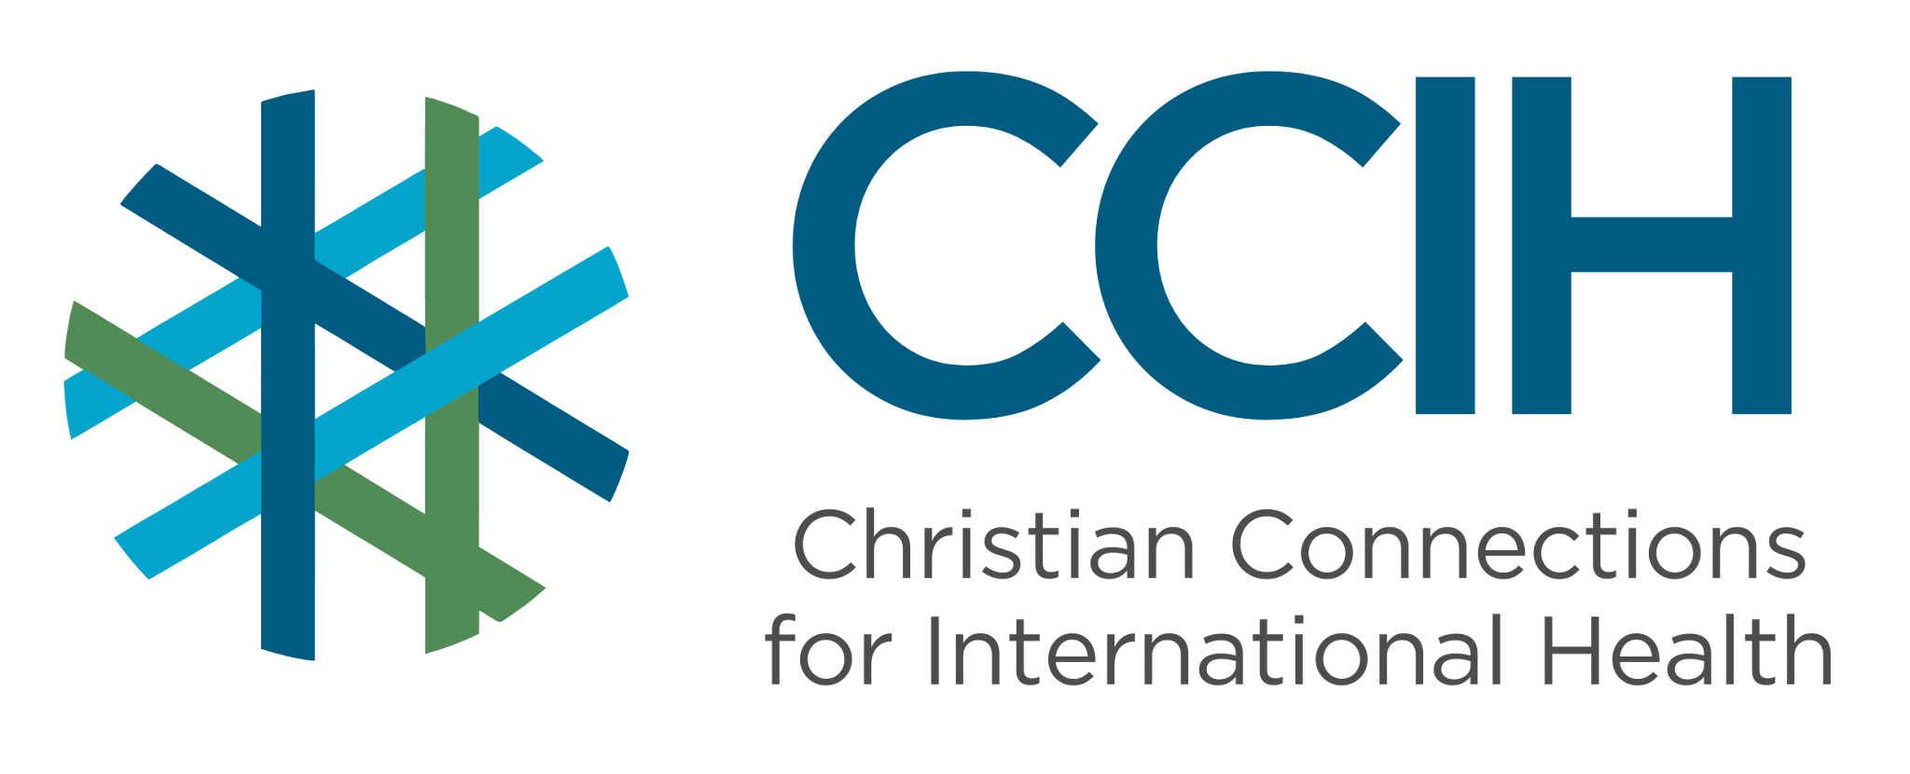
DOMESTIC RESOURCE ALLOCATION – Talking Points for Faith Actors

What is it?
Domestic resource mobilization for health means finding and using money from within a country, through government budgets, taxes, and national health programs, to pay for the healthcare that people need.

Why is it important?
For decades, many countries in Sub-Saharan Africa (SSA) relied heavily on money from other countries to provide healthcare. That money is now decreasing and may not return, while the people suffering the consequences are the poorest and most vulnerable. Increasing domestic resource allocation to build strong, sustainable health systems supported by local resources is about saving lives and treating people fairly.

Key Trends and Challenges
Current Trends and Statistics
- In 2024, USAID provided $12.7 billion in U.S. dollars to assist SSA, and much of it supported healthcare programs. In 2025, the United States shut down USAID and significantly decreased the money the U.S. gives to other countries. European donors are also reducing the money they give to other countries for healthcare.
- The Africa CDC estimates that 2–4 million additional Africans are likely to die every year because less money is being donated from other countries to support healthcare than before.
Challenges and Gaps in LMICs
- Most African governments are spending far less on health than they have promised. In the 2001 Abuja Declaration, African Union member countries said they would spend at least 15% of their country budgets on health, yet more than 20 years later, only three countries have consistently met that goal.
- More than 50 countries have reported that health workers are losing jobs and training programs are being reduced because money from other countries has decreased.
- Tax collection in many countries is weak, and money that leaves the country illegally through corruption and tax avoidance drains billions of dollars that could otherwise fund healthcare.
- Many governments do not have a plan for paying for healthcare. Without a plan, it is harder to set a budget and make sure health services receive long-term support.
Populations Most Affected
- People living with HIV who depend on externally funded medication programs; in some countries, people are already taking less medication or skipping doses.
- Pregnant women and children whose health services have been reduced or stopped.
- Communities in smaller, low-income countries where money donated from other countries paid for most healthcare.
- Health workers who have lost jobs or are working without pay as programs end.
- The poorest and most rural households who have no alternative when healthcare services close.

Christian Connections for International Health (CCIH) is a global network of Christian organizations and individuals committed to advancing health and wholeness. Learn more at www.ccih.org.

A Faith-Informed Response
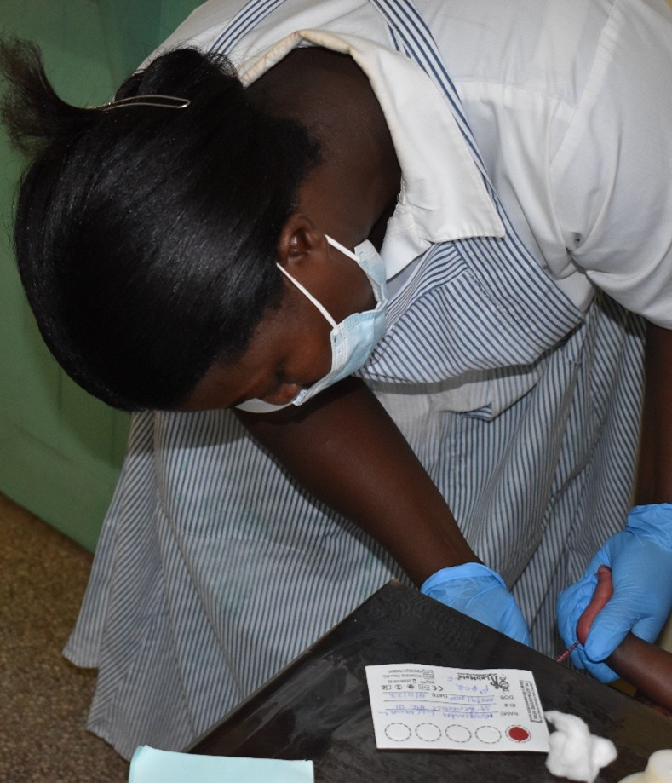
How are faith communities impacted?
- The results of less money donated from other countries are already being felt in faith communities across SSA. Medical clinics have closed, medicines have run out, and many skilled health workers lost their jobs. Many people who benefited from healthcare supported by money from other countries are now without the care they need.

Why does this matter to faith communities?
- A government that allows its people to go without basic healthcare because it chose not to fund it, when the money exists, is failing in one of its most important duties. The Bible calls leaders to seek justice for the poor and vulnerable. The health of a nation's people reflects the values of its leaders. When governments do not spend enough money on health, while the most vulnerable suffer and die, that is a justice issue, and the church is called to address it. Faith communities have a long history of advocating for the dignity and rights of the poor, and this moment calls for that voice again.

Why should religious leaders act?
- Governments across SSA are under enormous pressure right now due to debt, financial difficulties, and the sudden loss of money donated from other countries. Because of this situation, decisions about how to spend government money will define who lives and who dies. The people who will die if governments do not act cannot speak for themselves in the halls of power, but faith leaders can.

Related Scriptures

- "Speak up for those who cannot speak for themselves, for the rights of all who are destitute." Proverbs 31:8, NIV
- "Learn to do right; seek justice. Defend the oppressed. Take up the cause of the fatherless; plead the case of the widow." Isaiah 1:17, NIV
- "If anyone has material possessions and sees a brother or sister in need but has no pity on them, how can the love of God be in that person?" 1 John 3:17, NIV

Talking Points for Sermons, Meetings, and Social Media
Key Messages to Share
- Money from other countries for health programming is decreasing, and the people affected are the poorest and most vulnerable members of our communities.
- African governments made a promise in 2001 to spend at least 15% of their budgets on health. Most have not kept that promise. Now is the time to hold them accountable.
- A government that invests in the health of its people is not spending money; it is building a nation. Our leaders must be called to act.
How to Start the Conversation
- "The clinics that cared for our people, the medicines that kept our brothers and sisters alive, the money that paid for them has been cut. Our governments must now step up. And we must call them to do it."
- Share that African countries have both the obligation and, in many cases, the money to pay for their own health systems if governments choose to prioritize it.
- Point out that some governments are already responding; in 2025, Nigeria increased its health budget by $200 million to offset a decrease in money from other countries, and Ghana increased its own funding for health care by removing a limit on money collected for national health insurance.
- Call your congregation to pray specifically and regularly for the expansion of health resources in your country.

Practical Actions for Faith Leaders and Communities
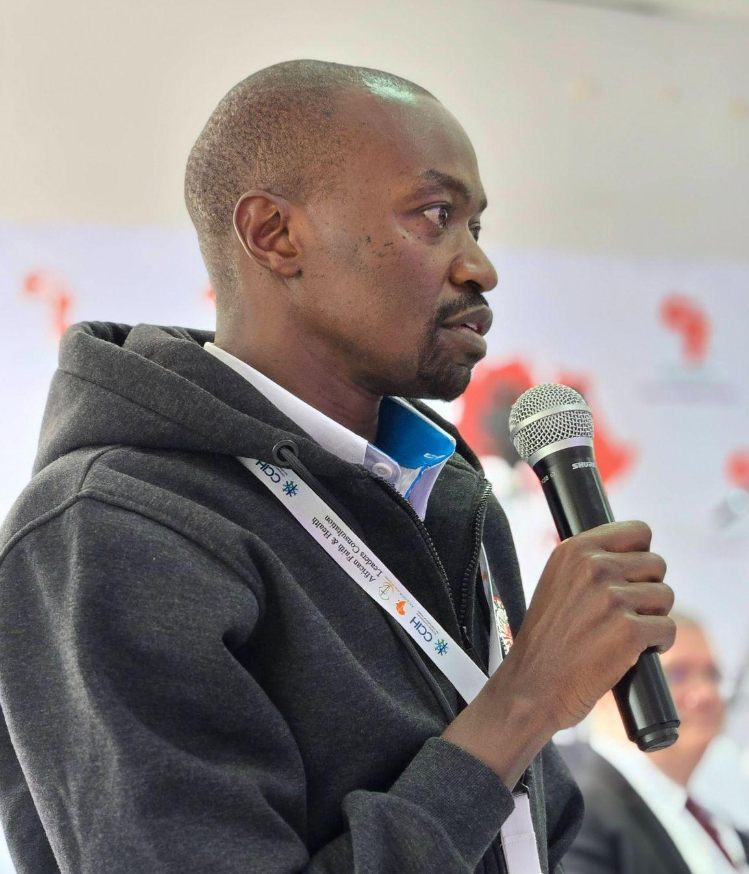
Advocate
- Use your position to call on your government to honor its 2001 Abuja Declaration commitment to use at least 15% of the country's budget for healthcare and to explain publicly why it has not yet done so.
- Engage with your Members of Parliament or government representatives directly by requesting meetings, writing letters, and working together with the community of faith leaders to increase the call for your country to invest more money in healthcare for its citizens.
- Join or support organizations and health advocacy groups in your country that are already asking governments to increase funding for healthcare.
Address Stigma and Misconceptions
- Challenge the idea that spending money on healthcare is someone else's responsibility, that money donated from other countries will always be there, or that governments cannot afford to do more. The fact is that many countries can do more if healthcare is made a genuine priority.
- Correct the misconception that advocating for government health spending is a political act that faith leaders should avoid. Caring for the sick and protecting the vulnerable is at the heart of the gospel, and calling governments to do the same is a deeply faithful act.
- Speak openly about the real human cost of funding cuts, the mothers who lost access to prenatal care, the children who went without vaccinations, and the people living with HIV who ran out of medicine, so that the urgency of this issue is felt and understood.
Refer People to the Right Services
- Stay informed about which health services are still available in your area and share that information regularly with your faith community. When programs are cut, people often do not know where else to turn.
- Connect faith community members who have lost access to medicines or health services to community health workers, local health authorities, or alternative programs that may still be operating.
- Direct faith leaders and health advocates in your network to the World Health Organization's guidance on health financing responses and to Africa CDC resources, so they are equipped to speak with knowledge and confidence when engaging with governments.

Resources

- For additional faith-based advocacy tools and biblical resources, visit the Christian Connections for International Health (CCIH) Resource Library, where you can search for “Financing” at https://www.ccih.org/resources/
- One Faith, One Voice: A Shared Commitment to Health and Wholeness in Africa. A Statement from Christian Faith and Health Leaders in Africa. 2025. https://www.ccih.org/wp-content/uploads/2025/11/Unity-Statement-2025-African-Faith-Health-Leaders.pdf
- WHO. Responding to the Health Financing Emergency: Immediate Measures and Longer-Term Shifts. Geneva: WHO, November 2025. https://www.who.int/news/item/03-11-2025-who-issues-guidance-to-address-drastic-global-health-financing-cuts
- Africa CDC. Africa's Health Financing in a New Era. April 2025. https://africacdc.org/news-item/africas-health-financing-in-a-new-era-april-2025/
- Africa Practice. USAID Cuts: Six Months On. July 2025. https://africapractice.com/insights/usaid-cuts-six-months-on/
- Chatham House. Africa After USAID: Who Will Pay the Health Bill? October 2025. https://www.chathamhouse.org/2025/10/africa-after-usaid-who-will-pay-health-bill
- Brookings Institution. Mobilizing Africa's Resources for Development. February 2026. https://www.brookings.edu/articles/mobilizing-africas-resources-for-development/
- Center for Global Development. A New Era for Global Health: Can African Countries Agree a New Compact with External Donors? March 2025. https://www.cgdev.org/publication/new-era-global-health-can-african-countries-agree-new-compact-external-donors
Why Does this Matter to Me? (Context-Specific) Use this space to write down your thoughts, prayers, data, or talking points.

