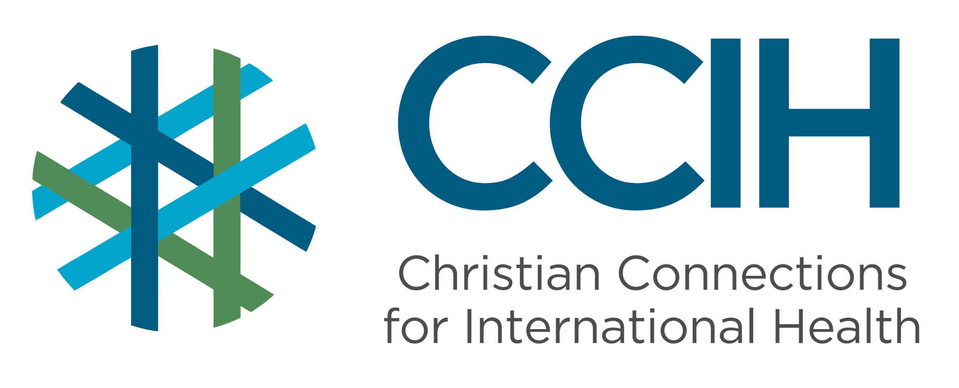
HEALTH IN CONFLICT SETTINGS – Talking Points for Faith Actors

What is it?
Health in conflict settings refers to the physical, mental, and social well-being of people living in areas affected by armed conflict, violence, or war. Conflict does not just harm people through direct violence; it destroys hospitals and clinics, drives away health workers, cuts off supplies and medicine, forces people to flee their homes, and creates the conditions for disease to spread rapidly. In conflict zones, getting basic health care can be difficult, and in some cases, impossible.

Why is it important?
Sub-Saharan Africa (SSA) is home to nearly half of the countries in the world dealing with war, violent conflict, and weak governments. People living in these areas are far more likely to die from preventable diseases, untreated injuries, malnutrition, and the breakdown of health services than from direct violence itself. Addressing health in conflict settings is not only a medical challenge, but it is a moral and humanitarian obligation that faith communities are uniquely positioned to respond to.

Key Trends and Challenges
Current Trends and Statistics
- SSA has the highest number of people forced to flee their homes and communities in the world; a record 38.8 million people fled due to conflict and violence as of the end of 2024, representing 46% of the global total.
- Africa has 183 million children living in conflict zones, the highest number of any region in the world.
- In 2024, more than 3,600 attacks on health workers, hospitals, and clinics in conflict zones were documented globally. On average, health care came under attack ten times every day.
Challenges and Gaps in LMICs
- When conflict breaks out, health facilities are frequently attacked, looted, or forced to close, leaving entire communities with no access to medical care.
- Health workers flee conflict zones for their own safety, creating severe shortages of skilled staff in the places where they are needed most.
- Conflict causes disease to spread rapidly by destroying water and sanitation systems, forcing people into crowded camps, and interrupting vaccination programs, leading to outbreaks.
- Women and girls in conflict zones face dramatically increased risks of sexual and gender-based violence, with limited access to support services.
- Mental health needs surge in conflict settings, but mental health services are almost entirely absent in these environments.
Populations Most Affected
- Children, who make up the majority of people in many conflict-affected areas and face the highest death rates.
- Women and girls, who face heightened risks of sexual violence, complications from pregnancy and childbirth, and loss of access to health care.
- People who have fled their homes but remain in their own country, who are cut off from their communities and health services and often living in overcrowded, unsanitary conditions.
- People living with chronic illnesses such as HIV, TB, or diabetes, whose treatment is disrupted when health systems collapse.
- Elderly people and people with disabilities, who are least able to flee and most vulnerable when services disappear.

Christian Connections for International Health (CCIH) is a global network of Christian organizations and individuals committed to advancing health and wholeness. Learn more at www.ccih.org.
A Faith-Informed Response
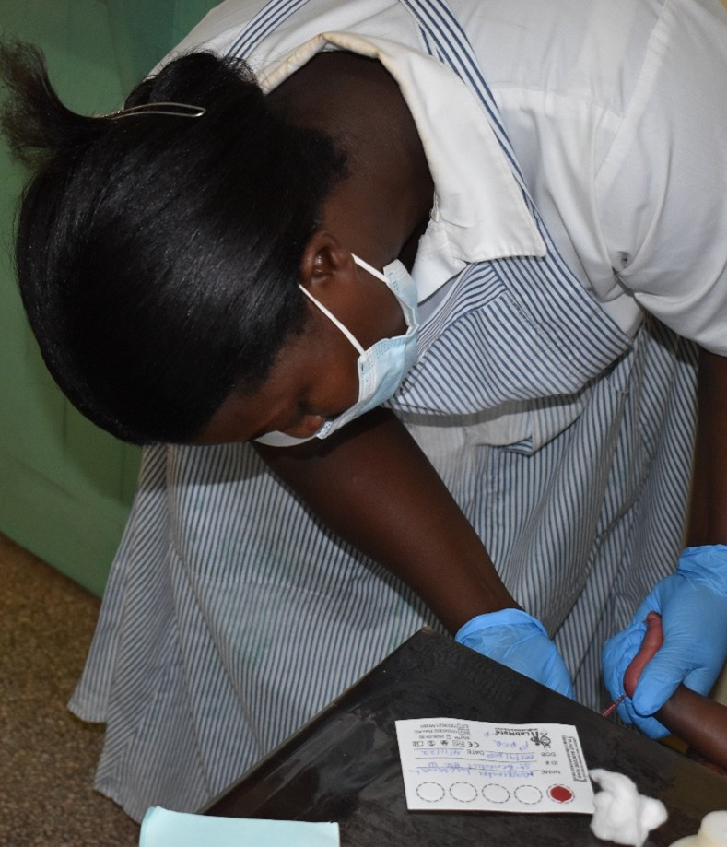
How are faith communities impacted?
- Conflict tears faith communities apart because congregations are scattered when people are forced to flee violence, and churches are sometimes destroyed or occupied. Those who remain in affected areas carry the weight of grief, trauma, and physical illness with almost no outside support. Even in communities not directly caught in conflict, the arrival of people fleeing violence brings new and urgent needs like people who are sick, traumatized, malnourished, and without any access to the services they once had. The church is often the first place people seek help, and sometimes the only institution available when everything else has collapsed.

Why does this matter to faith communities?
- The Bible is clear about the call to care for the stranger, the refugee, and those who are suffering from violence and fleeing their homes. The people most affected by conflict in SSA, including displaced mothers, orphaned children, survivors of sexual violence, and the sick and the injured, are exactly the people that Christ calls us to serve. The health crisis in conflict zones is also a justice crisis.

Why should religious leaders act?
- People living in conflict zones are among the most voiceless and overlooked in the world. They cannot advocate for themselves in halls of power, and they are often invisible to the outside world. Religious leaders, both those inside conflict-affected areas and those with influence beyond them, can be their voice. Pastors can speak up for peace, call on governments and armed groups to protect health facilities and civilians, mobilize their faith communities to support displaced communities, and create spaces of safety, healing, and dignity. In some conflict settings, the local church is the only trusted institution left, and that is precisely when its voice matters most.

Related Scriptures

- "The foreigner residing among you must be treated as your native-born. Love them as yourself." Leviticus 19:34, NIV
- "Defend the weak and the fatherless; uphold the cause of the poor and the oppressed. Rescue the weak and the needy; deliver them from the hand of the wicked." Psalm 82:3–4, NIV
- "Whatever you did for one of the least of these brothers and sisters of mine, you did for me." Matthew 25:40, NIV

Talking Points for Sermons, Meetings, and Social Media

Key Messages to Share
- There are 183 million children living in conflict zones in Africa right now. Their health, their safety, and their futures depend on whether the rest of us are willing to speak up and act.
- Attacking hospitals and health workers is a violation of international law and a violation of our shared humanity. The perpetrators must be held accountable.
- The church has always been called to serve the sick, welcome the stranger, and care for those affected by violence. Conflict zones are where that calling is urgent.
How to Start the Conversation
- "If people arrived at our church door tonight, displaced, sick, and with nowhere to go, what would we do? That is the reality for millions of people in our region right now. Our faith demands a response."
- Share that most deaths in conflict zones are not caused by violence itself, but by the collapse of health systems, preventable diseases, untreated wounds, and childbirth complications that would be manageable in a functioning health system.
- Call your congregation to pray specifically and regularly for communities affected by conflict in your region, naming specific countries or areas where conflict is ongoing.

Practical Actions for Faith Leaders and Communities

Advocate
- Use your voice to call on your national government to protect civilians and health facilities during conflict and to uphold their obligations under international humanitarian law.
- Join or support organizations and coalitions that document attacks on health facilities and call for accountability.
- Call on your congregation and your government to welcome and care for refugees and those forced from their homes by conflict, reminding both that the Bible is clear about our duty to the stranger and the displaced.
Address Stigma and Misconceptions
- Challenge harmful attitudes toward displaced people, including the idea that refugees or internally displaced persons are a burden or a threat. They are neighbors, made in the image of God, who deserve welcome and care.
- Correct the misconception that survivors of conflict-related violence are somehow to blame for what happened to them. Create a culture of compassion and confidentiality in your congregation where survivors feel safe to seek help.
- Address the stigma around mental health in conflict settings. Trauma, grief, and fear are normal human responses to violence, and those experiencing them deserve support, not silence or shame.
Refer People to the Right Services
- Know which humanitarian organizations, UN agencies, and health services are operating in your area and share that information with displaced families or those affected by conflict who come to your church for help.
- Connect survivors of sexual or gender-based violence to medical care as quickly as possible, ideally within 72 hours, and to counseling and legal support services where available.
- Direct those showing signs of trauma, depression, or post-traumatic stress to mental health support services or community health workers, and be a consistent source of pastoral care and follow-up for those in your congregation who are affected.

Resources

- For additional faith-based advocacy tools and biblical resources, visit the Christian Connections for International Health (CCIH) Resource Library, where you can search for “Emergency Response,” and “Migration” at https://www.ccih.org/resources/
- Medical Ambassadors International Academy. Bible Lessons: Disasters, online course: https://maiacademy.thinkific.com/courses/bible-lessons-disasters
- Biblica. When Your Whole World Changes. 2020. https://ccih.s3.amazonaws.com/wp-content/uploads/2023/03/06122354/When-Your-Whole-World-Changes-EN.pdf
- Internal Displacement Monitoring Centre. Global Report on Internal Displacement 2025. Geneva: IDMC, 2025. https://www.internal-displacement.org/global-report/grid2025/
- WHO Regional Office for Africa. Regional Committee for Africa Report: Accelerating Progress in the Health and Well-Being of Women, Children, and Adolescents. Brazzaville: WHO, July 2025. https://www.afro.who.int
- Safeguarding Health in Conflict Coalition. Epidemic of Violence: Violence Against Health Care in Conflict 2024. 2025. https://insecurityinsight.org/projects/healthcare/shcc
- IMF. Pushed to the Brink: Fragility and Conflict in Sub-Saharan Africa. IMF Notes, 2025. https://doi.org/10.5089/9798229008792.068
- Nasreldin M et al. Humanitarian Strategies for Tackling Public Health Crises in Conflict Zones in Africa. Journal of Public Health in Africa, 2024. https://www.ncbi.nlm.nih.gov/pmc/articles/PMC11622516/
- Physicians for Human Rights. Massive Influx of Cases: Health Worker Perspectives on Conflict-Related Sexual Violence in Eastern DRC. October 2024. https://phr.org/our-work/resources/massive-influx-of-cases-sexual-violence-drc/
- World Relief https://worldrelief.org/humanitarian-and-disaster-response/
Why Does this Matter to Me? (Context-Specific) Use this space to write down your thoughts, prayers, data, or talking points.

