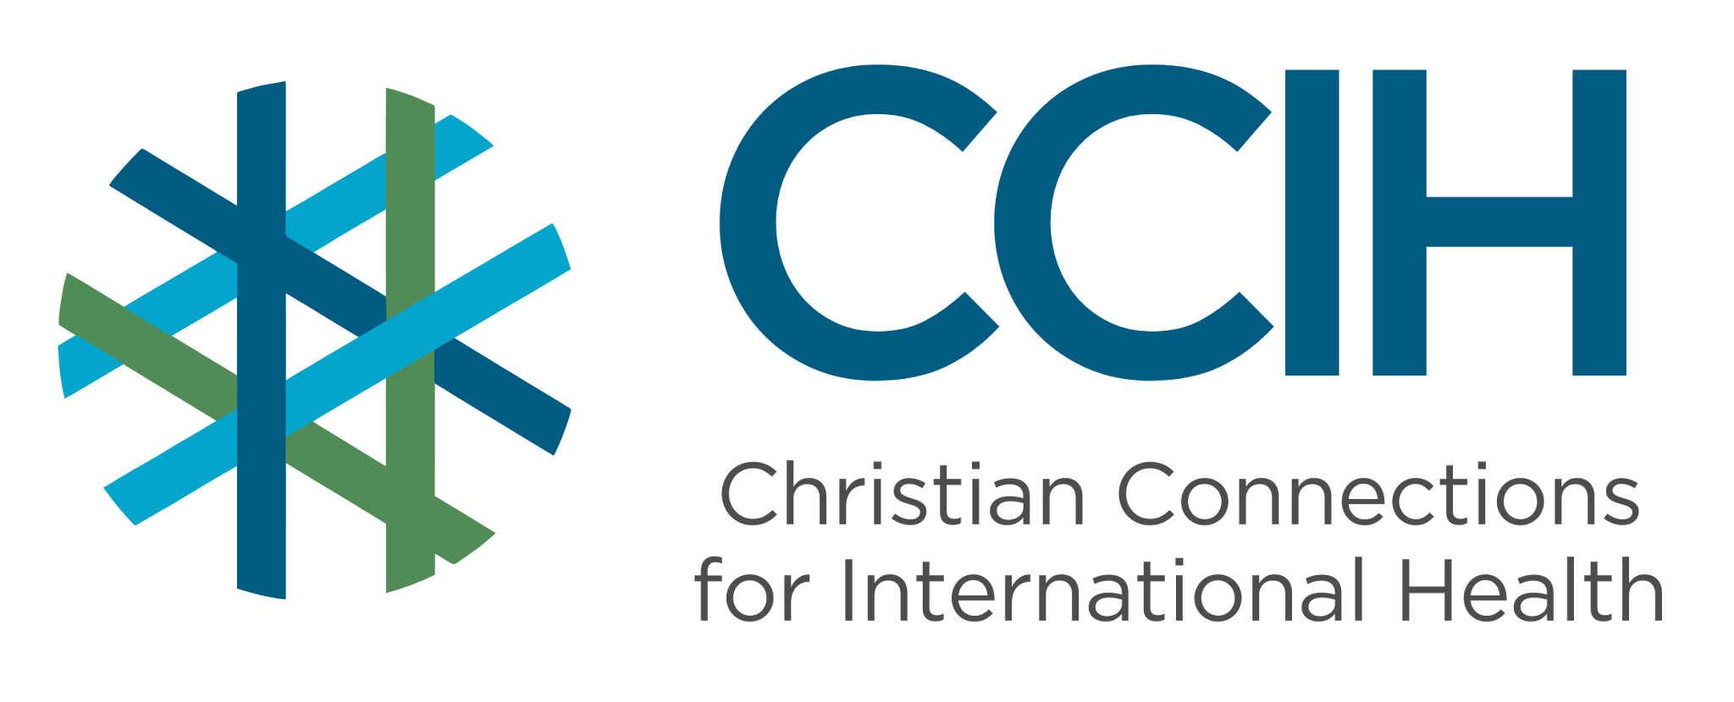
MENTAL HEALTH – Talking Points for Faith Actors

What is it?
Mental health refers to our emotional, psychological, and social well-being; this includes how we think, feel, and cope with daily life. Mental health conditions include depression, anxiety, trauma, and psychosis, among others. Mental health conditions are not a sign of weakness or a lack of faith; they are health conditions, just like diabetes or malaria, and many respond well to care and treatment.

Why is it important?
Mental health conditions are one of the leading causes of disability in the world, yet in Sub-Saharan Africa (SSA), most people who need help never receive it. Untreated mental illness affects every part of a person's life, including their ability to work, care for their children, maintain relationships, and participate in community life. With the right support, most people living with mental health conditions can recover and live full, productive lives.

Key Trends and Challenges

Current Trends and Statistics
- More than one billion people worldwide are living with a mental health condition, making it one of the most pressing public health challenges globally.
- In SSA, fewer than 10% of people living with a mental health condition ever receive professional care.
- The burden of mental health conditions in Sub-Saharan Africa is projected to increase by 130% by 2050 if urgent action is not taken.
Challenges and Gaps in LMICs
- There is a severe shortage of trained mental health professionals across SSA, with some countries having fewer than one psychiatrist for every million people.
- Many people with mental health conditions first seek help from traditional or faith-based healers, which can delay access to medical treatment.
- Deep stigma causes many people to hide their mental health struggles and suffer in silence.
- Conflict, poverty, food insecurity, and disease outbreaks significantly increase the risk of mental health conditions, while at the same time making services even harder to access.
Populations Most Affected
- Women, who face higher rates of depression and anxiety, often linked to gender-based violence, poverty, pregnancy, childbirth, and caregiving burdens.
- Children and adolescents exposed to violence, poverty, conflict, or loss of a parent.
- People living with chronic illnesses such as HIV, TB, or diabetes, who face higher rates of depression and anxiety.
- Survivors of conflict, displacement, or trauma.
- People living in rural areas, where mental health services are almost absent.
- People living in extreme poverty, where daily stress and hardship take a heavy toll on mental well-being.

Christian Connections for International Health (CCIH) is a global network of Christian organizations and individuals committed to advancing health and wholeness. Learn more at www.ccih.org.

A Faith-Informed Response
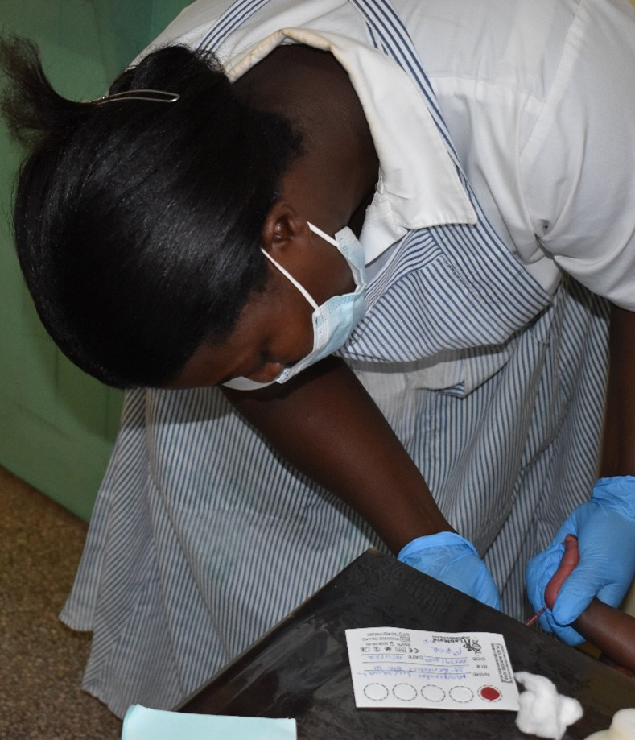
How are faith communities impacted?
- Mental health struggles are present in every faith community, even when they are not spoken about. Members living with depression, anxiety, grief, or trauma sit in the pews every week, often suffering alone because they fear judgment or do not know where to turn. People are quietly struggling under the weight of untreated mental illness, resulting in broken relationships and, in the most tragic cases, suicide. Pastors and faith leaders are often the first, and sometimes the only, people these individuals reach out to. The church is already on the front line of mental health issues.

Why does this matter to faith communities?
- God created us as whole people, body, mind, and spirit. Caring for mental health is part of our faith. When a member of our congregation is suffering from depression or trauma, our calling is the same as when someone has malaria or a broken bone: to show compassion, to help them find care, and to walk with them through their pain and difficulties. The church should be the safest place in the community for someone to say, "I am not okay," and to find love and support.

Why should religious leaders act?
- People living with mental health conditions are among the most stigmatized and voiceless in our communities. They are often too ashamed, too unwell, or too afraid of being misunderstood to speak up for themselves. Religious leaders can be their voice, naming mental health openly from the pulpit, challenging the harmful belief that mental illness is a spiritual failure, and pointing people toward care. In a region where professional mental health services are scarce, the church's role is essential. A church that takes mental health seriously can change the culture of an entire community.

Related Scriptures

- "Come to me, all you who are weary and burdened, and I will give you rest." Matthew 11:28, NIV
- "The Lord is close to the brokenhearted and saves those who are crushed in spirit." Psalm 34:18, NIV
- "Carry each other's burdens, and in this way you will fulfill the law of Christ." Galatians 6:2, NIV

Talking Points for Sermons, Meetings, and Social Media

Key Messages to Share
- Mental health conditions are real health conditions. They are not a punishment from God, a sign of weak faith, or something to be ashamed of.
- Just as we would encourage someone with malaria to seek medical care, we should encourage those struggling with their mental health to seek help.
- Our church is a place where no one should have to suffer alone, including those living with depression, anxiety, or trauma.
How to Start the Conversation
- "How many of us have lost sleep from worry, felt too sad to get out of bed, or felt like life was too heavy to carry? Mental health affects all of us, and God meets us in those places too."
- Acknowledge that suffering is real and that seeking help is an act of courage, not weakness.
- Share the effective mental health help that exists in your community, including community health workers, counselors, and trained health professionals who can support people living with mental health conditions.
- Call your faith community to pray specifically and regularly for people living with mental health issues in your community.

Practical Actions for Faith Leaders and Communities

Advocate
- Preach openly about mental health, naming depression, anxiety, grief, and trauma as real conditions that deserve care.
- Partner with a local health worker or counselor to offer a mental health awareness session at your church, where congregation members can learn about the signs of mental illness and where to seek help.
- Advocate with local health leadership for mental health services to be available and affordable in your community.
Address Stigma and Misconceptions
- Clearly and consistently challenge the belief that mental illness is caused by sin, witchcraft, or weak faith; these beliefs cause real harm and keep people from getting help.
- Correct the idea that prayer alone is always sufficient, and that seeking professional help is a sign of spiritual failure; faith and medical care can and should work together.
Refer People to the Right Services
- Connect congregation members who are struggling with their mental health to resources and services in your area.
- Be aware of the warning signs of a mental health crisis, such as talk of hopelessness, self-harm, or suicide, and respond quickly and compassionately by helping the person access care immediately.
- Build relationships with local health workers and counselors so that you have trusted people to refer congregation members to when they need professional support.

Resources

- For additional faith-based advocacy tools and biblical resources, visit the Christian Connections for International Health (CCIH) Resource Library, where you can search for “Mental Health” at https://www.ccih.org/resources/
- Pfeiffer, Erin; Bormet, Mona; Church, Deirdre; Stalls, Suzanne; Fitzgerald, Laura; McNab, Shanon; Kinsella, Caroline; and Doggett, Elizabeth. 2023. Maternal Mental Health: A Toolkit for Engaging Faith Actors as Change Agents. Washington, DC: USAID MOMENTUM. https://jliflc.com/wp-content/uploads/2025/01/MCGL-Maternal-Mental-Health-Toolkit-Final.pdf
- Worby, P., & Jailer, T. (2025). Promoting community mental health. Hesperian Health Guides. https://en.hesperian.org/hhg/Promoting_Community_Mental_Health
- National Action Alliance for Suicide Prevention, Suicide Prevention Resource Center, & U.S. Department of Health and Human Services Center for Faith-based and Neighborhood Partnerships. (2023). Hope: A guide for faith leaders to help prevent youth suicide. The Board of Regents of the University of Oklahoma. https://www.ccih.org/wp-content/uploads/2025/03/hope-guide-faith-leaders-help-prevent-youth-suicide.pdf
- Arigatou International Geneva, KAICIID International Dialogue Centre and World Vision International. Faith-sensitive Mental Health and Psychosocial Support (MHPSS) to Foster Resilience in Children on the Move. 2021. https://ethicseducationforchildren.org/wp-content/uploads/2022/06/Resilience-in-Children-on-the-Move-Booklet.pdf
- World Health Organization. Mental Health Atlas 2024. Geneva: WHO, 2025. https://www.who.int/publications/i/item/9789240114487
- UNICEF/WHO. Mental Health a Human Right, but Only 1 Psychiatrist per 1,000,000 People in Sub-Saharan Africa. Joint Statement, October 2023. https://www.unicef.org/esa/press-releases/mental-health-a-human-right
- WHO Regional Office for Africa. Barriers to Mental Health Care in Africa. Brazzaville: WHO, 2022. https://www.afro.who.int/news/barriers-mental-health-care-africa
- Komu CK, Ngigi M, Melson AJ. Barriers and Facilitators to Accessing Mental Health Services for Adults in Sub-Saharan Africa: A Systematic Review. Mental Health Science, 2025. https://doi.org/10.1002/mhs2.70006
- Atewologun F et al. A Comprehensive Review of Mental Health Services Across Selected Countries in Sub-Saharan Africa. Discover Mental Health, 2025. https://link.springer.com/article/10.1007/s44192-025-00177-7
- Charlson FJ et al. Mental and Substance Use Disorders in Sub-Saharan Africa: Predictions of Epidemiological Changes and Mental Health Workforce Requirements for the Next 40 Years. PLOS ONE, 2014. https://www.ncbi.nlm.nih.gov/pmc/articles/PMC4195720/
- World mental health today: latest data. Geneva: World Health Organization; 2025. Licence: CC BY-NC-SA 3.0 IGO. https://iris.who.int/server/api/core/bitstreams/31714489-1345-4439-8b37-6cbdc52e15ca/content
Why Does this Matter to Me? (Context-Specific) Use this space to write down your thoughts, prayers, data, or talking points.

