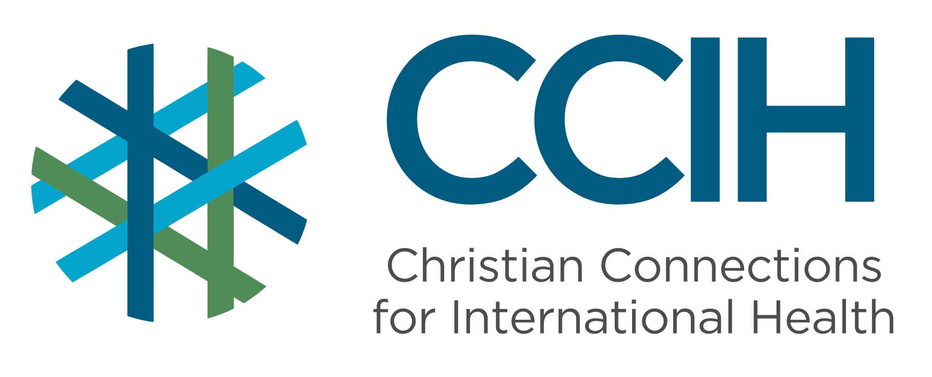
OUTBREAK PREPAREDNESS AND RESPONSE – Talking Points for Faith Actors

What is it?
"Outbreak preparedness and response" refers to the systems, plans, and actions that communities, health facilities, and governments put in place to detect, contain, and recover from the rapid spread of dangerous diseases. These include cholera, Ebola, mpox, and COVID-19. Preparedness means being ready with a strategy before a disease strikes, having trained health workers, and having a way to track and report when people get sick. Response means acting quickly and effectively when an outbreak does occur to stop the spread of disease and save as many lives as possible.

Why is it important?
Sub-Saharan Africa (SSA) carries the heaviest burden of disease outbreaks of any region in the world, and outbreaks are becoming more frequent. When an outbreak strikes a community that is not prepared, the consequences can be catastrophic and result in preventable deaths. The difference between a contained outbreak and a devastating disease that spreads and becomes out of control is often not the disease itself, but how quickly and effectively the community and health system respond. Faith communities are a critical and often overlooked part of that response.

Key Trends and Challenges
Current Trends and Statistics
- There were 87 disease outbreaks in 2024 alone in SSA, the highest number of any subregion in the world.
- Public health emergencies in the World Health Organization African Region surged 41% between 2022 and 2024, exposing severe gaps in health infrastructure and workforce capacity.
Challenges and Gaps in LMICs
- Disease tracking and monitoring systems across SSA remain inconsistent and underfunded. That means that many outbreaks are detected late, giving diseases time to spread before a response can begin.
- Low vaccination coverage in many communities leaves populations vulnerable to outbreaks of measles, diphtheria, cholera, and other preventable diseases.
- Most countries in SSA lack sufficient numbers of trained emergency response workers, laboratories, and stockpiles of vaccines and medicines to respond quickly when outbreaks occur.
- Misinformation and mistrust cause people to avoid health services, hide illness, or reject vaccines, allowing outbreaks to grow unchecked.
- Climate change is making outbreaks worse because floods, droughts, and extreme weather events are increasing the frequency and severity of diseases.
Populations Most Affected
- Children under five, who are most vulnerable to cholera, measles, and other diseases.
- Communities in conflict-affected or displaced settings, where vaccination coverage is low, and health systems have collapsed.
- Rural and remote communities, where outbreaks can spread for weeks before being detected.
- People living in areas with poor water and sanitation infrastructure, where waterborne diseases spread rapidly.
- People with disabilities who cannot access care or receive prevention messages.
- Healthcare workers, who are on the front lines of every outbreak and may not be trained or have protective equipment.

Christian Connections for International Health (CCIH) is a global network of Christian organizations and individuals committed to advancing health and wholeness. Learn more at www.ccih.org.
A Faith-Informed Response

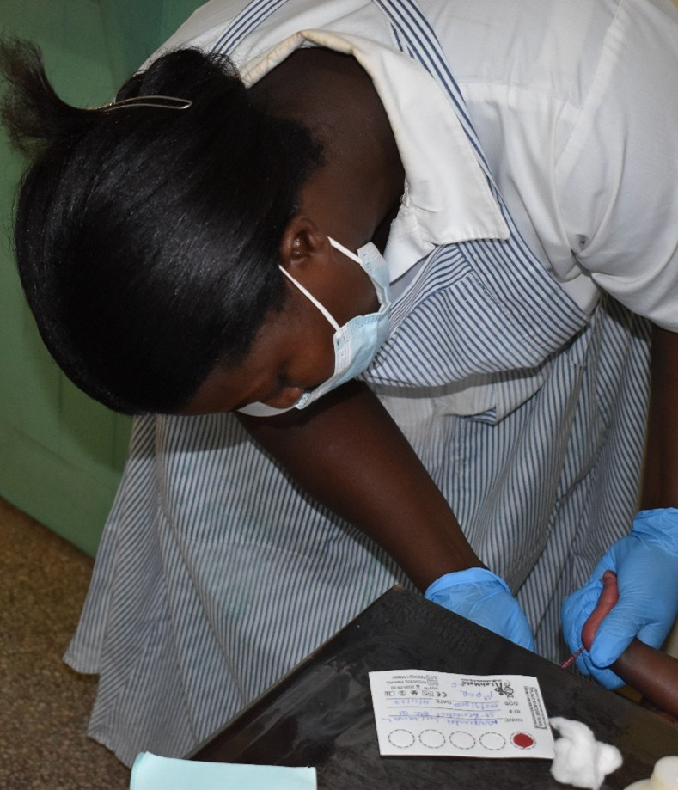
How are faith communities impacted?
- When disease strikes, faith communities feel it immediately and deeply. Congregations have watched outbreaks like Ebola, cholera, and COVID-19 kill members, shut down worship services, and spread in their community in a matter of days.
- Funerals, often large gatherings, have sometimes become sites of transmission, spreading disease further.
- Pastors have been called to comfort the dying without knowing how to protect themselves, and in communities where mistrust of health workers runs high, it is often the pastor, not the doctor, who people turn to first.

Why does this matter to faith communities?
- The God who heals also calls us to act wisely in the face of disease. Protecting our communities from outbreaks by supporting vaccination, encouraging people to report illness early, and cooperating with health authorities aligns with the basic principles of our faith. When communities are poorly prepared for outbreaks, the people who suffer most are the poorest and most vulnerable, the same people that Christ calls us to protect. Faith communities have a responsibility to be part of the solution when disease strikes.

Why should religious leaders act?
- In many communities across SSA, the pastor is the most trusted voice; religious leaders are often more trusted than government officials or health workers. That trust is both a gift and a responsibility. When misinformation about a disease or a vaccine spreads through a community, a pastor who speaks clearly and with accurate facts can stop fear from becoming fatal. When people are afraid to report illness or seek care, a pastor who accompanies them can save their life, and when governments are slow to prepare or respond to outbreaks, faith leaders who speak up can hold leaders accountable. Informed religious leaders are one of the most powerful assets a community has when disease strikes.

Related Scriptures

- "The prudent see danger and seek refuge." Proverbs 22:3, NIV
- "My people are destroyed from lack of knowledge." Hosea 4:6, NIV

Talking Points for Sermons, Meetings, and Social Media

Key Messages to Share
- SSA is the most outbreak-prone region in the world, and being prepared to manage and stop the spread of disease is vital.
- Vaccines, early reporting of illness, and cooperation with health workers are how we protect the lives that God has given us.
- Our church can be a source of correct medical information where people know what to do when disease strikes.
- During an outbreak, trust spreads just as quickly as fear. Churches help communities trust accurate information, support one another, and cooperate with public health measures.
- Effective outbreak preparedness depends on strong health systems, such as trained health workers, reliable laboratories, disease surveillance, community reporting, functioning supply chains, trusted local leadership, and clear communication between communities and government.
How to Start the Conversation
- "When Ebola came, when COVID came, when cholera struck, what did our community do? Were we ready? Did we know what to do? And are we more ready today than we were then?"
- Remind your congregation that most outbreaks can be contained quickly when communities respond early, report illness promptly, and follow the guidance of trained health workers.
- Acknowledge openly that the church has a responsibility to be a source of calm, accurate, and life-saving information.

Practical Actions for Faith Leaders and Communities
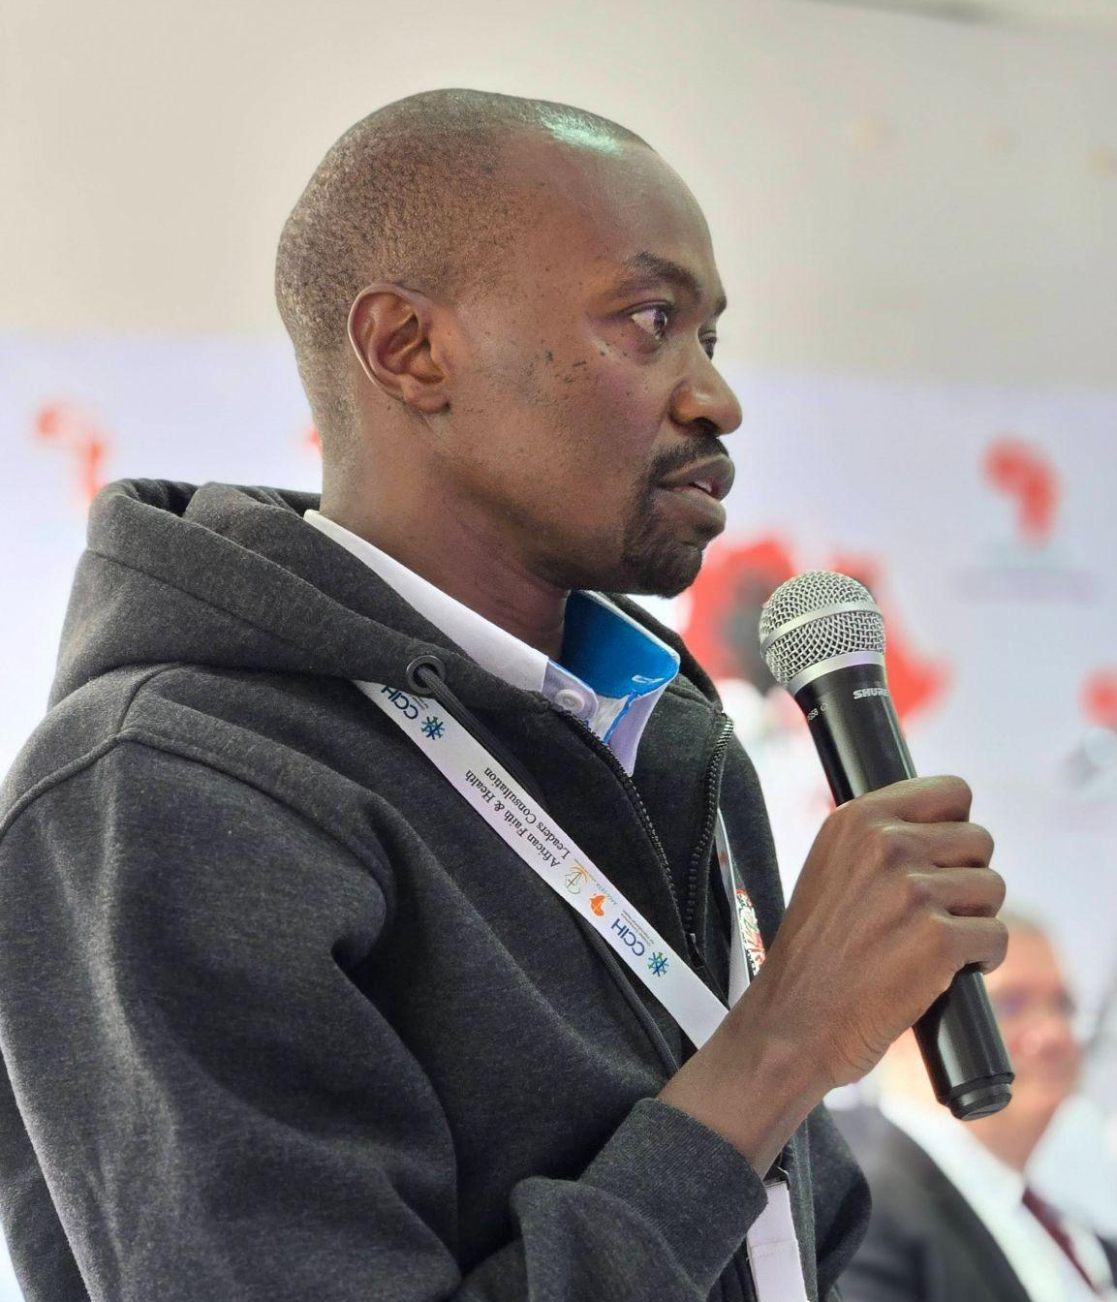
Plan
- Know who your local health officials are before an outbreak.
- Have a church communication plan. Know how to contact vulnerable members. Identify volunteers who could assist.
- Build trust before there is a crisis. Speak in sermons before a crisis hits. Make people aware.

Advocate
- Advocate with your local and national government for stronger disease tracking and monitoring systems, better-stocked community health facilities, and community-level outbreak response training, so that the next outbreak is discovered earlier and stopped faster.
- Use your platform to support vaccination campaigns in your community actively, publicly encourage faith community members to vaccinate themselves and their children, and consider hosting vaccination days at your church in partnership with local health authorities.
- Speak up and share facts when you see misinformation spreading in your community and direct people to accurate information from trusted health sources.
- Share the message among many clergy. It helps most when the entire community of faith leaders speaks with one voice.
Prepare People with Good Information
- Clearly explain that diseases are not a punishment from God while promoting effective medical ways to stop the spread of disease.
- Explain that prayer is a tool, and so is medical care. They can both be used.
- Create a culture in your congregation where people feel safe to report illness, seek care early, and follow the guidance of health authorities without shame or judgment.
- Speak publicly on the radio and in print media and on social media—share facts, encourage people.
Support People When They Need Help
- Know the signs and symptoms of the most common outbreak diseases in your area, and direct anyone showing these signs to the nearest health facility immediately.
- Support grieving families.
- Share public health hotlines, outbreak reporting numbers, and the locations of the nearest health facilities with your congregation regularly, not just during a crisis, but as part of ongoing community preparedness.

Resources

- For additional faith-based advocacy tools and biblical resources, visit the Christian Connections for International Health (CCIH) Resource Library, where you can search for “Ebola,” “Communicable Diseases,” “Pandemics and COVID” at https://www.ccih.org/resources/
- CCIH. Faith Engagement Guide for Ebola Response and Preparedness. 2026. https://www.ccih.org/resource_index/faith-engagement-guide-for-ebola/?resource_topics=ebola&s=&resource_type=#
- IMA World Health https://imaworldhealth.org/global-health-security
- Isaac Muyonga and Michael Beasley, Faith in Time of Ebola: Sermon Guide. English, French, Swahili. 2020. https://www.ccih.org/resource_index/faith-in-time-of-ebola-swahili/?resource_type=&s=&resource_topics=ebola
- Torres Munguía JA, Martínez-Zarzoso I. Global trends of pandemic-prone and epidemic-prone disease outbreaks in 2024. BMJ Global Health. 2026;11:e020708. https://doi.org/10.1136/bmjgh-2025-020708. https://gh.bmj.com/content/11/2/e020708
- WHO Regional Office for Africa. Ensuring Health Security in the WHO African Region: Quarterly Emergency Preparedness and Response, Q1 2024. Brazzaville: WHO, 2024. https://www.afro.who.int/publications/ensuring-health-security-who-african-region-quarterly-emergency-preparedness-and-0
- WHO Regional Office for Africa. Cholera in the WHO African Region. Brazzaville: WHO, 2024. https://www.afro.who.int/health-topics/disease-outbreaks/cholera-who-african-region
- WHO Regional Office for Africa. From Data to Decisions: Strengthening Health Security in Africa. Brazzaville: WHO, March 2026. https://www.afro.who.int/news/data-decisions-strengthening-health-security-africa
- Africa CDC. Africa's Health Financing in a New Era. April 2025. https://africacdc.org/news-item/africas-health-financing-in-a-new-era-april-2025/
- Ndembi N et al. Building Systems' Resilience in the Mpox Outbreak Response in Africa. BMC Infectious Diseases / Lancet Global Health, 2025. https://www.ncbi.nlm.nih.gov/pmc/articles/PMC11966670/
- Moyo E et al. Emerging Infectious Disease Outbreaks in Sub-Saharan Africa: Learning from the Past and Present to Be Better Prepared for Future Outbreaks. Frontiers in Public Health, 2023. https://www.ncbi.nlm.nih.gov/pmc/articles/PMC10203177/
- KFF. Global Disease Outbreaks: A 2025 Snapshot and Implications for the U.S. October 2025. https://www.kff.org/global-health-policy/global-disease-outbreaks-a-2025-snapshot-and-implications-for-the-u-s/
Why Does this Matter to Me? (Context-Specific) Use this space to write down your thoughts, prayers, data, or talking points.

